**Data Types in Python**

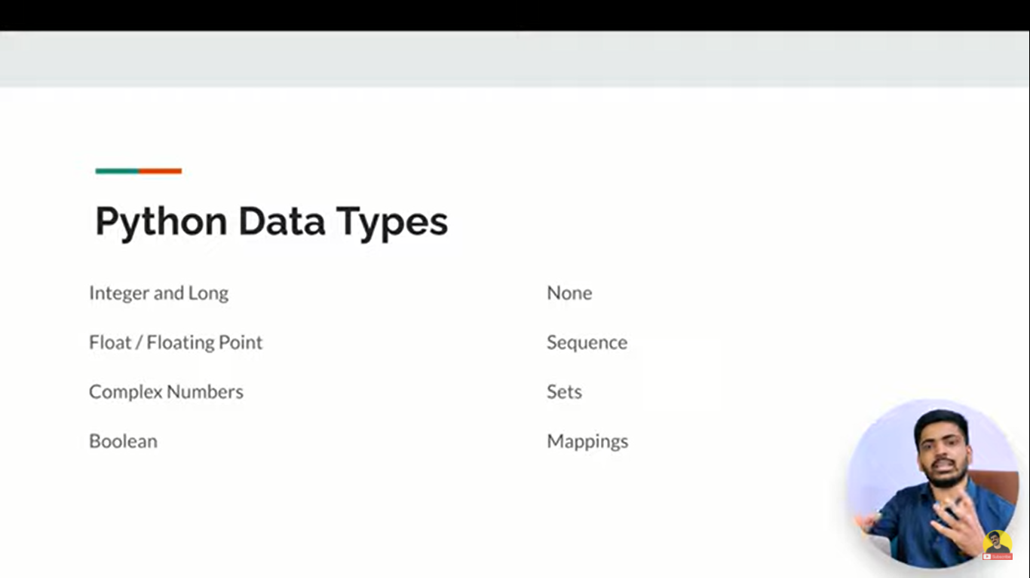

14:30 sec (Video Python by anuj bhaya)